Accessing Your Child’s Report Card

To digitally access your child’s report card, you will need to either log into your PowerSchool Parent Portal, or create your PowerSchool Parent Portal account. Both can be found at: https://powerschool.eips.ca/public/home.html. If you have forgotten your username or password, please click on the “Forgot Username or Password?”
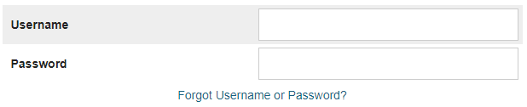

Once the account is created, parents will be able to manage their own account information and to link all of their students to one account. This account will remain in effect for the duration of the student’s enrollment in Elk Island Public Schools. If you are currently registered in the Parent Portal with junior and/or senior high students, you will now be able to add the elementary student. There is no need to create a new account. A video demonstrating the steps to creating a PowerSchool parent portal account is found at: http://www.eips.ca/powerschool. If you are having difficulty logging into your PowerSchool Parent Portal, please contact us at school.
Once you set up and/or log into your account, click on the “Communicating Student Learning” button. At the top left hand side of the screen. This will take you to the report card.
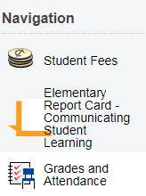

If you require a paper copy of the report card, please contact your child’s teacher and we will be happy to print one off for you.
Once you set up and/or log into your account, click on the “Communicating Student Learning” button. This will take you to the report card.
Click on a scale to view a description of the scale levels.
Click on the to expand subjects or comments.
If you wish to print the report card, scroll to the bottom of the page and click on the “print” button. You can either print the condensed or full version.

