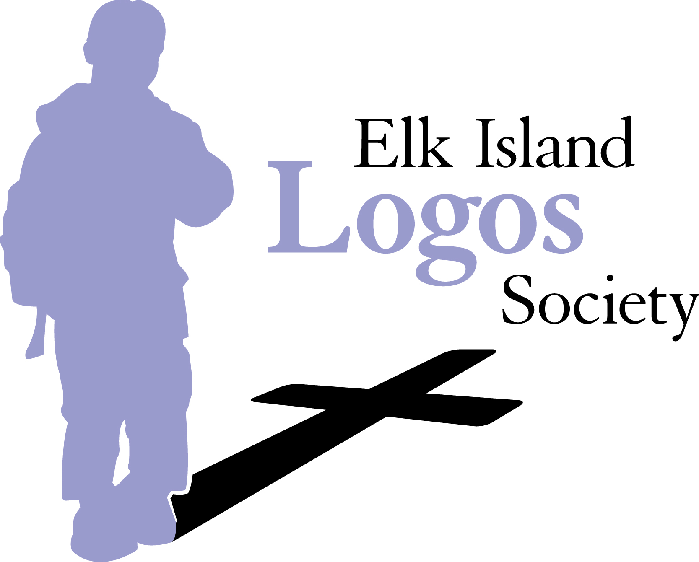
ELK ISLAND LOGOS SOCIETY BOARD MEETING
Tuesday, May 9, 2016 7:00
Sherwood Heights Junior High School

- Open in Prayer & Scripture -Kerry or Keela

- Personal intros

- Approval of March 2017 Minutes

- Approval of the Agenda

- Standing Items
  - School Reports
    - Brentwood Elementary Melanie or Tina

    - Westboro Elementary –Rachel or Krista

    - Sherwood Heights -Cheryl

  - Other Reports
    - Treasurer –Rebekah (discuss possible changes to budget for next year)

    - Advertising -Lynda

    - Easter joint chapel feedback

    - Fundraising –Jenn

    - Curriculum -Michelle

    - Bless the Teachers –Brooke & Melanie

- New Business
    - School Feedback from Brooke meeting with teachers
    - AGM discussion
-Positions up for election: Pres, Secretary, Directors 2 & 4.
-Positions not due: Vice-Pres, Treasurer, Directors 1, 3 & 5.
-Appointed positions: School Reps.
    - Grade 6 & 9 Year end gifts & retirements
6.1.6 Other
- Close in Prayer –Kerry or Keela

- Meeting Adjourned.
Next Meeting date–AGM Tuesday, June 13th, 7:00 pm @ BWD

