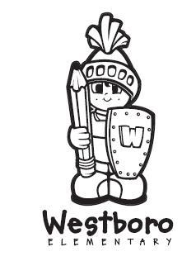
Westboro Elementary School
1078 Strathcona Drive
Sherwood Park, AB T8A 0Z9
780-467-7751 (phone)
780-467-3525 (fax)

Believe in Yourself ~ Imagine the Possibilities

November 27, 2015

Dear Parents,

Thank you for being a part of our new report card. Please make sure that you check out the digital version where you may access additional drop-down menus and links to learning scales and other information to provide a clearer picture of your child’s learning.

To view your child’s expanded digital report card, go to your PowerSchool account and select “Communicating Student Learning”.
We have sent home a great deal of information about this new report card over the past few months, but in case you still have questions, here are some places to start:

- The Westboro Elementary School website contains information on the home page and links to several documents that can help answer many questions about this new report card.

- https://powerschool.eips.ca/public/home.html. This website, found on the EIPS website, can help you set up your PowerSchool account.

- Additional information can also be found on the EIPS (Elk Island Public Schools) website at www.eips.ca

- Speaking directly with your homeroom teacher would also help answer any questions you may have.

Finally, we are also looking to gather parental input on this new report card. Please take the time to visit our school website and complete the two questions contained in the link: CSL Parent Feedback . We would sincerely appreciate it!
Thank you once again for your continued support as we work to refine our assessment and reporting practices. Please do not hesitate to contact us if you have any questions or concerns.
Sincerely,
Colleen Alpern
Principal

